FFPN Module 2 - Evaluation and Workup

1. Evaluation and Workup

1.1 Introduction


1.2 Making the Diagnosis
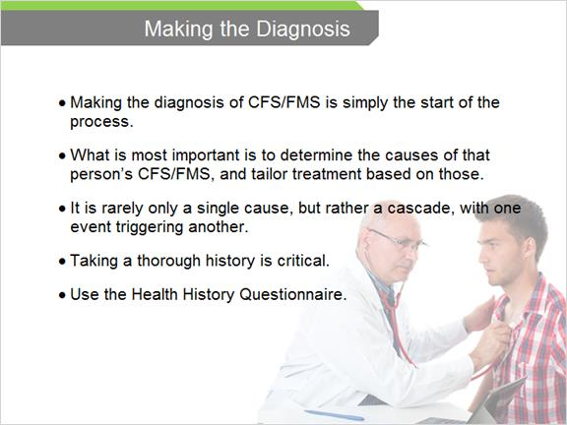

1.3 CFS/FMS Patient Questionnaires
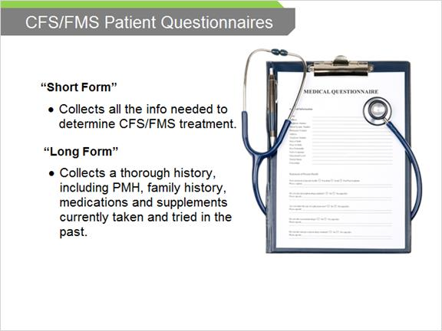

1.4 Which to Use
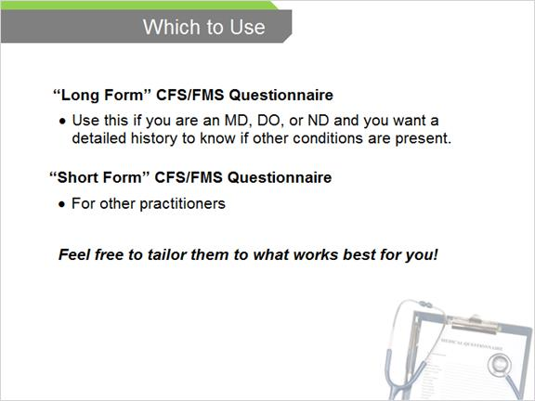

1.5 Legal Protection
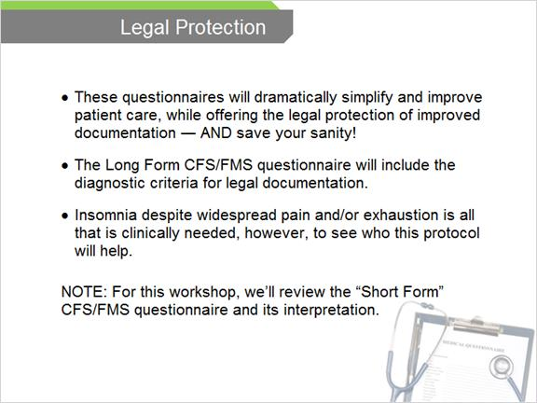

1.6 The Point-Scoring System
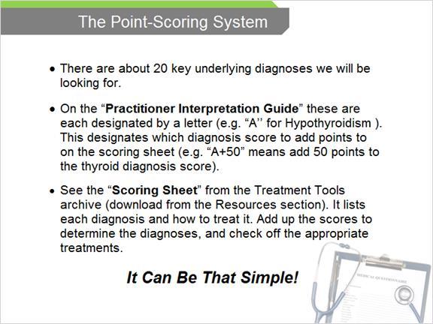

2. The Scoring Sheet

2.1 Using the Questionnaires


2.2 Scoring Sheet
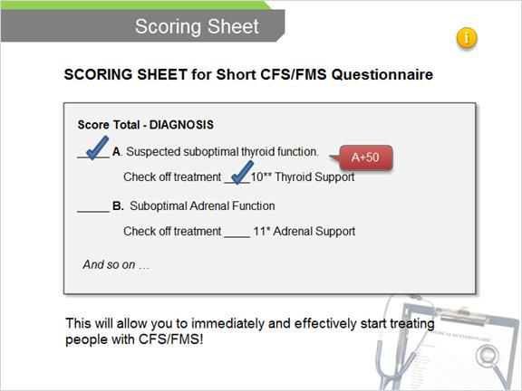

2.3 Interpreting the Answers
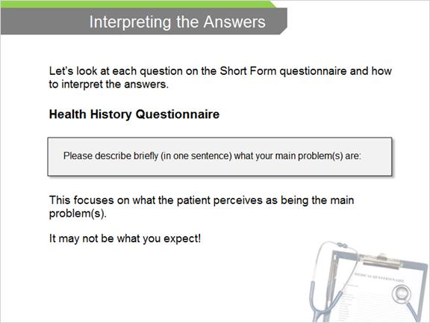

2.4 Assessing Causes/Triggers
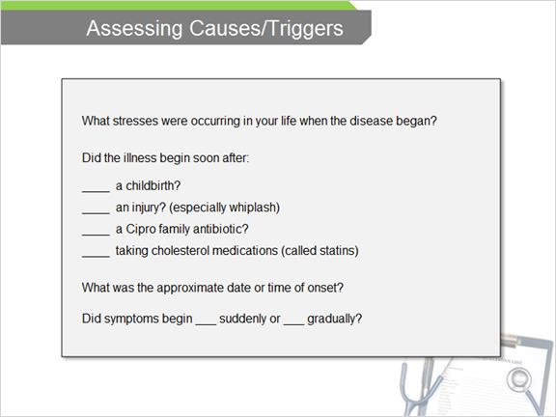

2.5 Triggers (What Blew the Fuse)
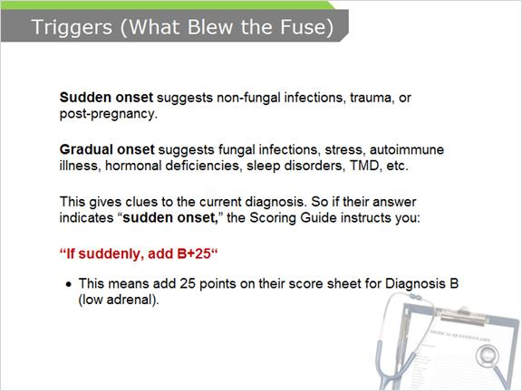

2.6 Total the Score
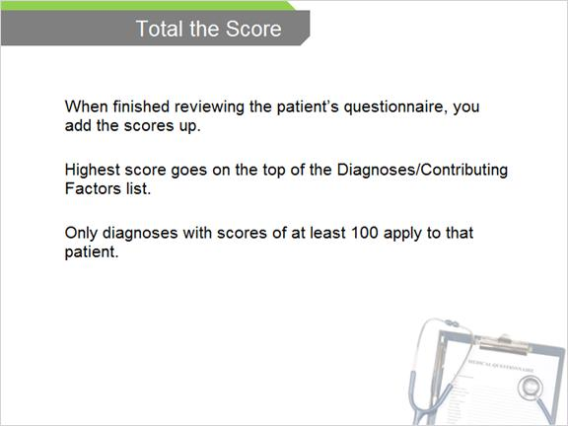

2.7 Other Illnesses
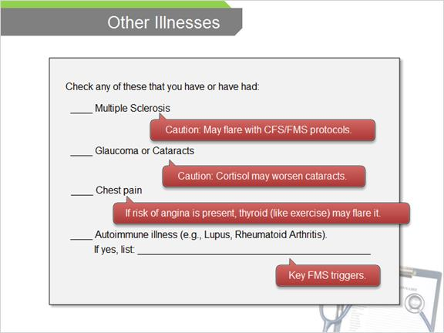

2.8 Thyroid Checklist (Diagnosis “A”)
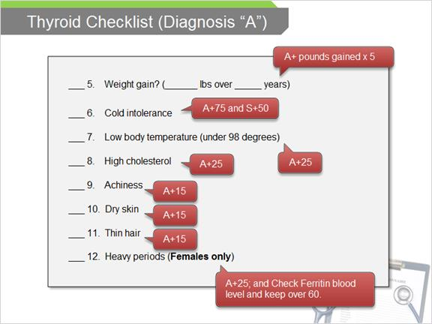

2.9 Adrenal Fatigue (Diagnosis “B”)
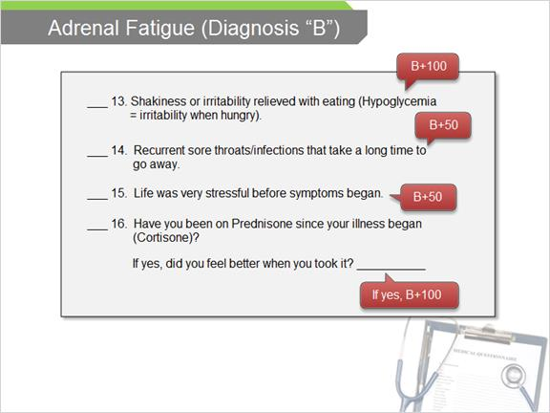

2.10 Estrogen/Progesterone Checklist
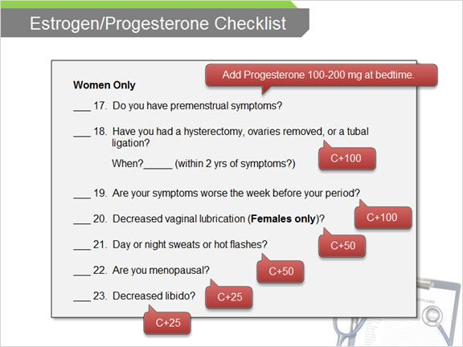

2.11 Testosterone Checklist
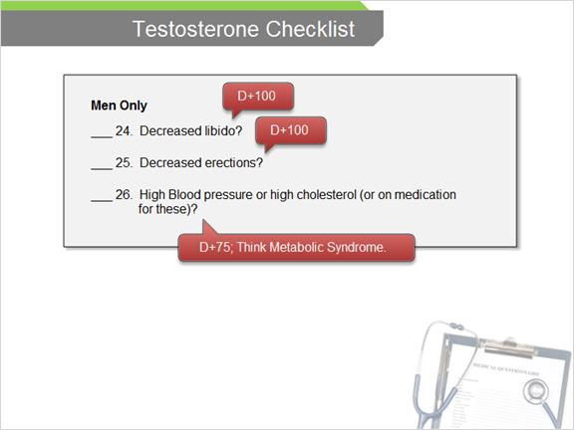

2.12 Disordered Sleep Checklist
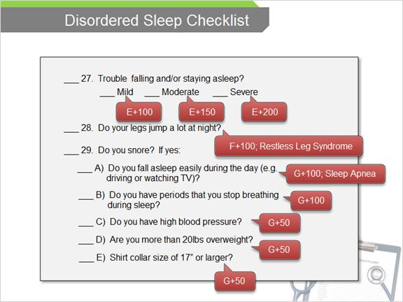

2.13 Infections
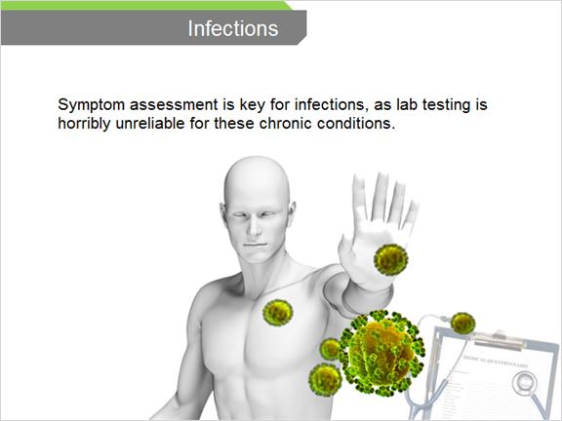

2.14 Yeast Questionnaire
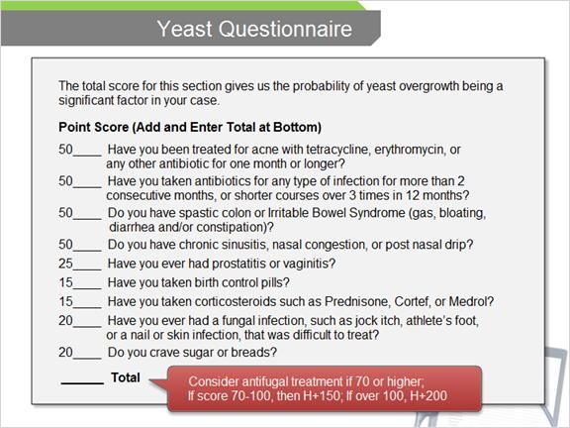

2.15 Parasites & Other Bowel Infections
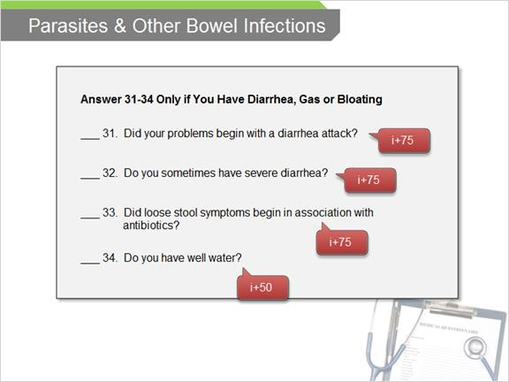

2.16 Sinusitis/Nasal Congestion
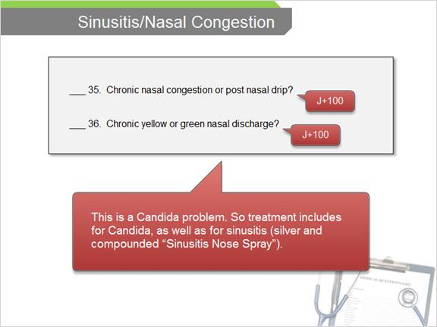

2.17 Other Antibiotic Sensitive infections
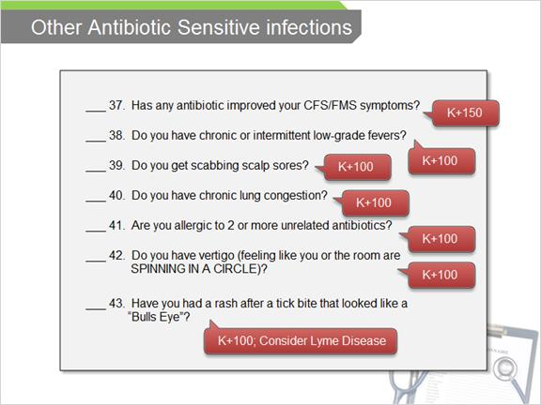

2.18 Other Infections
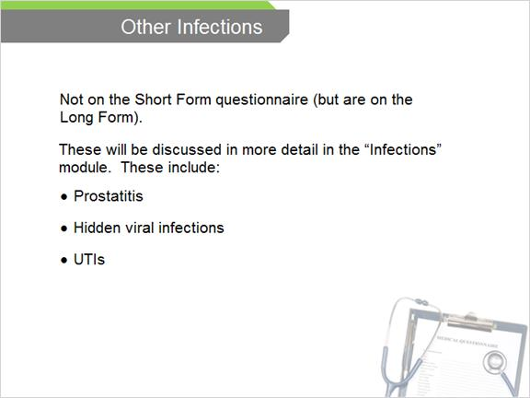

2.19 Essential Fatty Acid Deficiencies
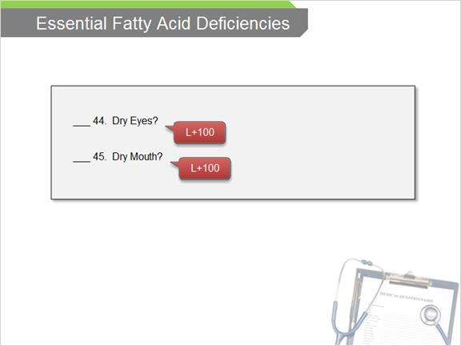

2.20 Vasodepressor Syncope (NMH/POTS)
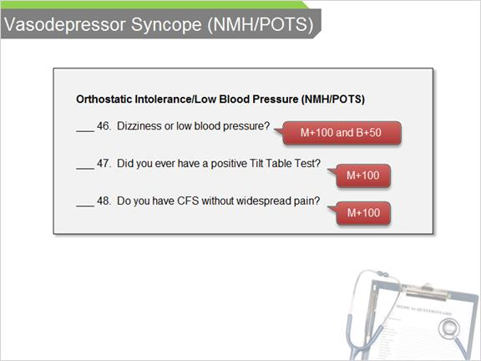

2.21 Anxiety/Hyperventilation
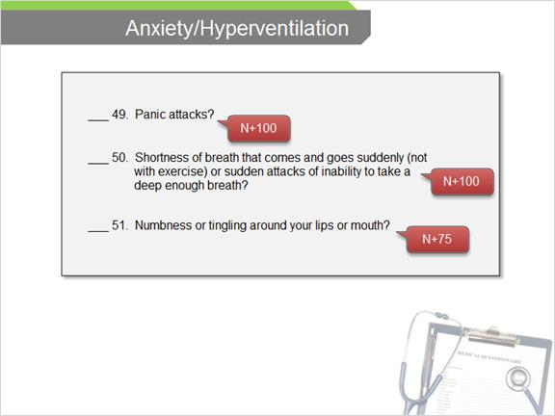

2.22 Depression
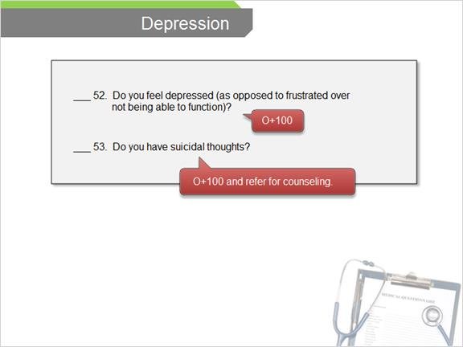

2.23 Patient's Experience with Illness
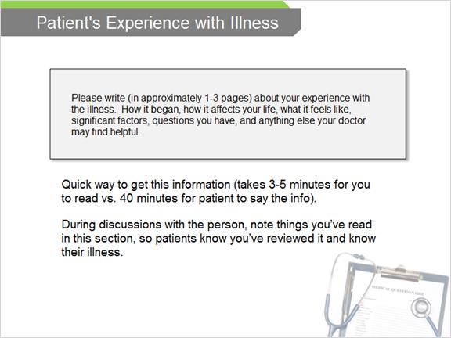

2.24 What Has Been Tried
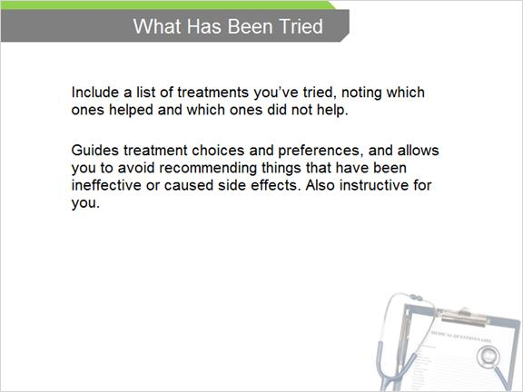

2.25 Physical Exam: CFS/FMS
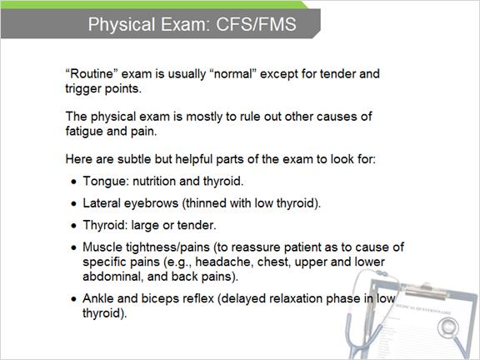

2.26 Tender Point Exam
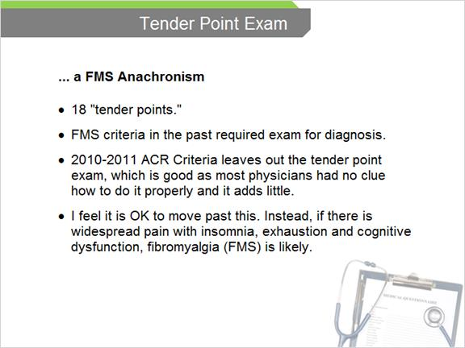

2.27 Lab Testing vs. Symptoms
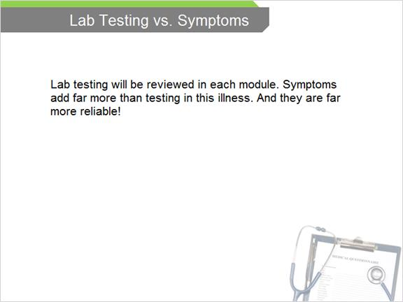

3. Review

3.1 Review


3.2 Question 1
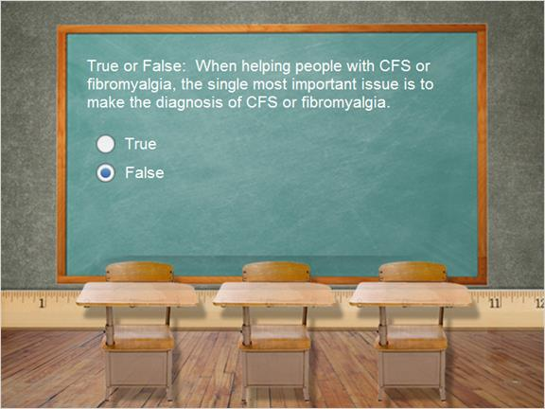

3.3 Question 2
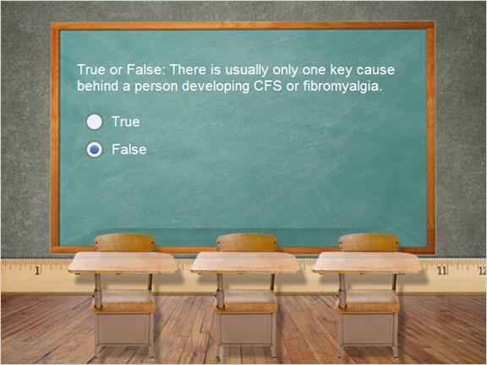

3.4 Question 3
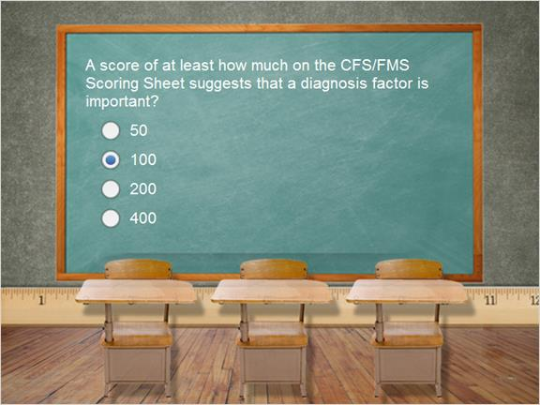

3.5 Question 4
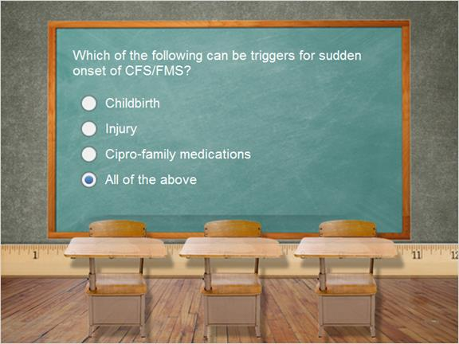

3.6 Question 5
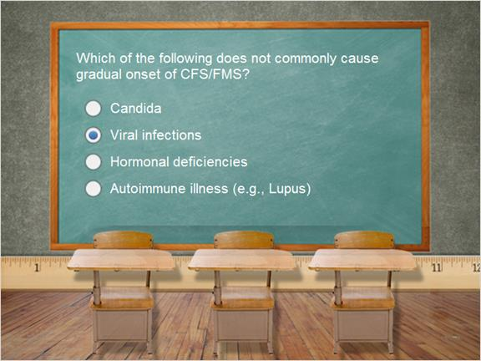

3.7 Question 6
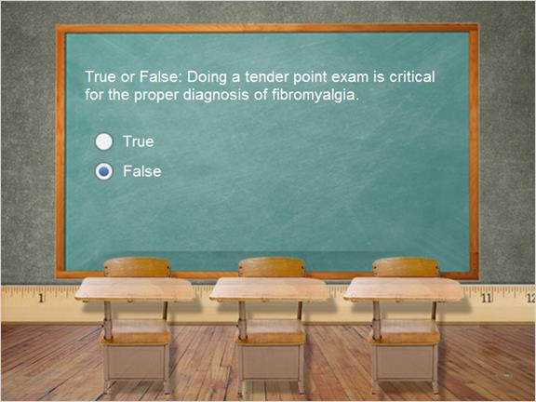

3.8 Results


